Python Numpy



import numpy as np

b=np.array([[1,2,3],

[4,5,6],

[8,9,10]])

Input: b[0:2,2]

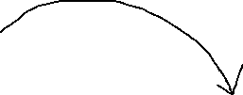

Output: array([3, 6])

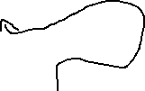

0 1 2

0

1



2

3

Input: for row in b :

print(row)

Output: [1 2 3]

[4 5 6]

[ 8 9 10]

* Input: for cell in b.flat:

print(cell)

Output:

1

2

3

4

5

6

8

9

10

|  |  |  |
| --- | --- | --- |
| 1 | 2 | 3 |
| 4 | 5 | 6 |
| 8 | 9 | 10 |